Question 6 [6 Points]

Create a shell script metrics.sh that analyzes a text file input.txt.The script should display:
• Longest word
• Shortest word
• Average word length
• Total number of unique wordsUse pipes and commands such as tr, sort, uniq, wc.
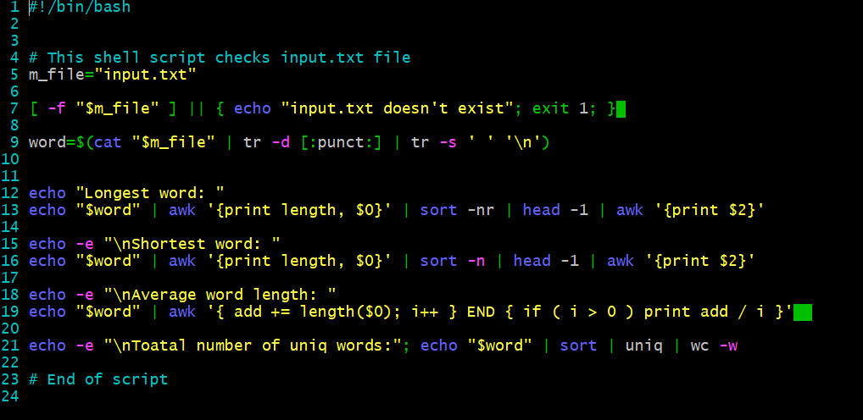
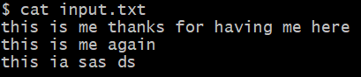
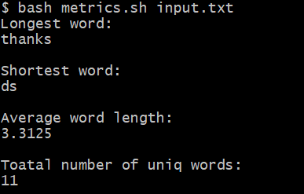
Explanation: Above scripts is used check input.txt file an display the longest word as well as shortest word. Also does the average word count with total number of uniq words. Here I used tr command to delete and remove extra spaces. Pipeline command helped to pass output to another command as input. And with help of awk command to print out the words. I got the desired output, screenshots are attached.

